Name: ___________________ Class: ____
Science 9 Environmental Issues Case Study: An Inconvenient Truth
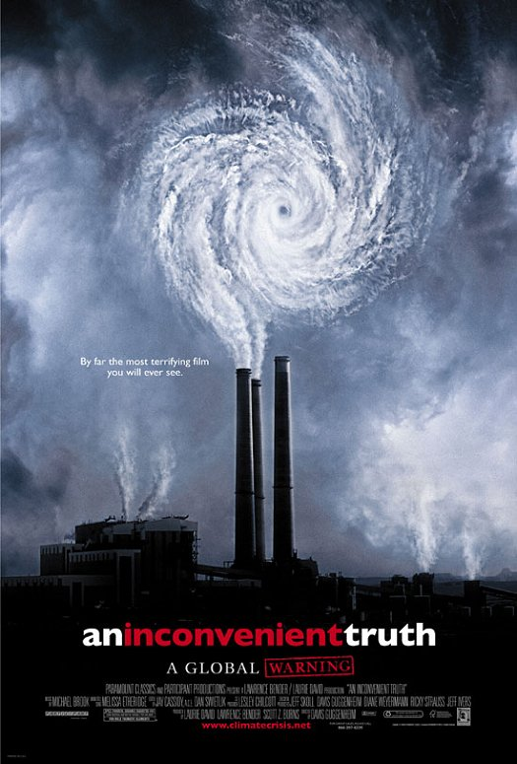
Today in class you will be watching the documentary An Inconvenient Truth. By watching this, you will be looking at an examination of Man-kind’s effects on the environment and the potential risks in place with our modern, industrialized culture. Issues such as Global Warming, Natural Resource Depletion, Atmospheric Consequences, Polar Ice Sheet Diminishment, Enhanced Greenhouse Effect and Carbon Emissions will be discussed from a Scientific and Political standpoint. It is essential that you take active notes during the film as you will be required to write a 1-page response due next Wednesday.

Notes:

Your Turn!
You will now provide a 1-page response to the film and its points of discussion regarding the environment and the human impact that scientist have observed over the past decades.
Your focus question is…
Formulate an opinion either for or against the issue of Global Warming. Present AT LEAST 3 arguments to support your stance and provide scientific evidence to strengthen your arguments. Be sure to critically analyze the points made in the film in providing your answer. (10 Marks)

